# Axis Mail Dates File Load and Reporting Process

We get files with Mail Date information from Axis after we send files to them. We currently get files for several different types of letters. These are currently

* CMR
* TMR
* Offers
* Others

The intention is that files will be pulled down manually from the “From Axis” folder on their ftp site and placed into the “AutoDownload” folder located here: \\sqlrdp.ad.pharmmd.com\external\Fulfillment\AutoDownload

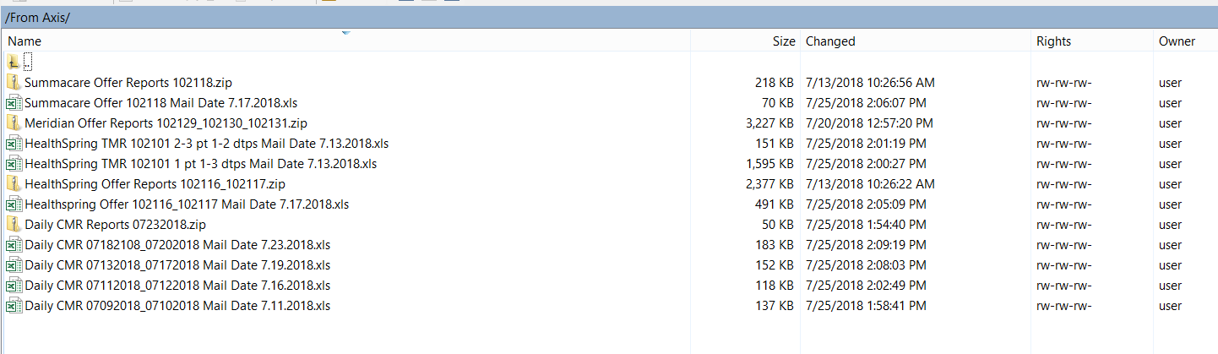

The files are staged and loaded from this location:

\\sqlrdp\ssis\DocumentCampaigns\OfferLetterPostalReports\Stage

The Stage folder listed above is manipulated and cleared via the application. If any special files need to be put in the run, they can be placed here and they will be copied (one-time) to Stage – similar folder structure as above.

\\sqlrdp\ssis\DocumentCampaigns\OfferLetterPostalReports\MANUAL

# SSIS Solution:

The file loading has been bolted on to an existing process: The Prioritize Likely to Fail Offer Letters process.

\\sqlrdp\artifacts\prod\com.pharmmd.OperationsSupport.prioritizeLikelyToFailOfferLetters\prioritizeLikelyToFailOfferLetters

## SSRS Report Link:

<http://p10prdsrs001/Reports/Pages/Report.aspx?ItemPath=%2fIT%2fAxis+Mail+Dates>

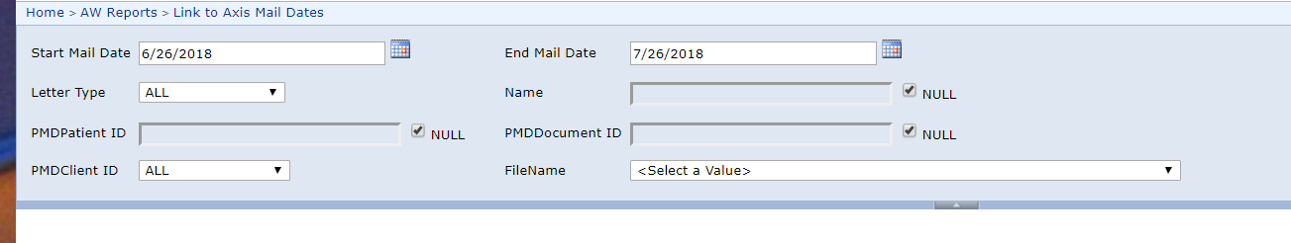

You can slice the data by a number of options – by patientid, name , client, incoming file name, etc.

NOTE: We do NOT have the information to properly get the PMDPatientID for all reports. This is true for most CMR letters. You will have to search by patient name in that instance.